Meet the team:
Year Reception
Autumn 1 Newsletter 2021

EYFS Lead RA Teacher RB Teacher
Mrs McCarthy Mr. Currie Mrs. Burgess

Teaching Assistants: Miss Hamlet, Miss Hughes, Mrs Nadeem and Mrs Jannath

Returning to School
The children should arrive at school at 8.40am. Learning takes place as soon as they enter school and this is a very important time of the day, please bring your children to school promptly. RA children will be in Mr. Currie’s class, RB children will be in Mrs. Burgess’s class. All children will enter through the main playground. The children will be collected at 3.15 at the same door.

Topic Overview & Key Text
We will look closely at two traditional tales to support our learning in this first half term.

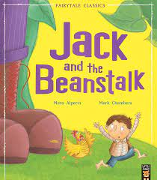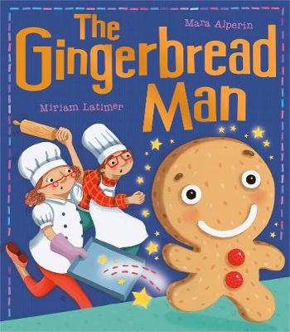

Jack and the Beanstalk
A children's story. Jack, a poor country boy, trades the family cow for a handful of magic beans, which grow into an enormous beanstalk reaching up into the clouds. Jack climbs the beanstalk and finds himself in the castle of an unfriendly giant.
The Gingerbread Man
The cheeky little gingerbread man is having so much fun! He scurries away from Mr and Mrs Baker and all the hungry animals, but then he meets a crafty fox … Will the gingerbread man meet a sticky end?

Maths
Number Recognition
Place value numbers to 5
Addition and subtraction to 5
Time- My week
Please see the ‘End of Year Expectations’

on our website for a full list of math’s concepts that will be taught this year.
Writing
The Children will be practising to write their name and making sure each letter is correctly formed.
The children will be creating a story map to retell the main events of ‘The Gingerbread Man Story.’
and adding labels or initial sounds.
Reading
The children will be practising their
Set 1 sounds and learning how to read simple words.

Linked texts we will be reading; -

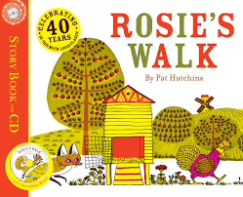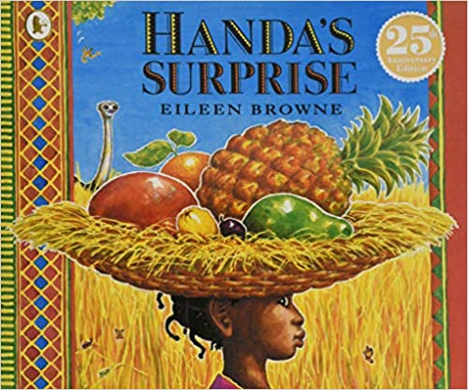

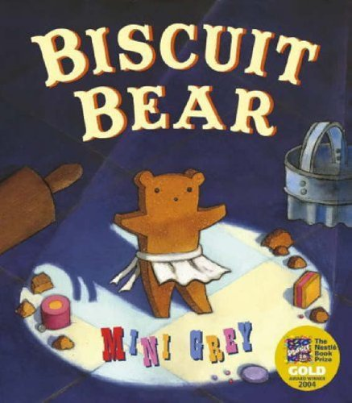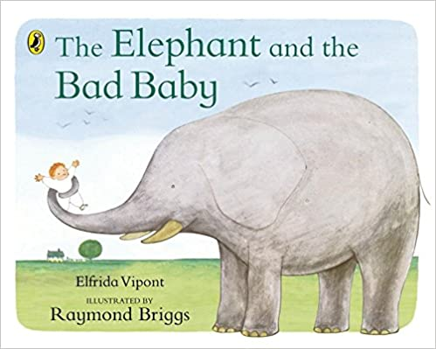

Homework
Your child will get a book to take home, this is a book for you to read to your child. They will also get a set of sounds and green words to practise reading at home.
Autumn/Harvest
We will also be looking at the changes in our environment as we will look at how we begin to see the season change into Autumn. What can we see outside? How does it feel?
We will also be looking at the festival ‘Harvest’
‘What is Harvest and how do we celebrate it? and ‘How is Harvest celebrated in the UK?’
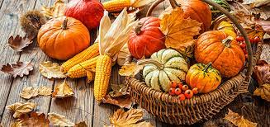
We will also look at other celebrations that happen in Autumn such as Halloween.
RE and Worship
We will look at ‘special people’ beginning with why we ourselves are special and learn all about being a good friend and what makes a good friend. We will learn about our feelings and how we learn to understand our feelings and the feelings of others.

We will meet ‘Jack’ our class friend who will help us to learn about compassion and courage.

Reception
Date & Routines

School opens for all pupils on Thursday 1st September 2022.

We will inform you about PE in a different letter in the coming days.

Mondays | Tuesdays | Wednesdays | Thursdays | Fridays
Book bags in school. | Book bags in school. | Book bags in school. | Book bags in school.  Set homework. | Book bags in school.  Green Treat

