Year 2
Autumn 1 Newsletter 2022

Meet the Team

 | Mr  Smith |  | Miss  Clarke
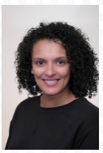  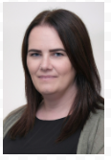 | Miss Currey  Mrs  Graham | 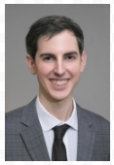  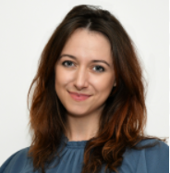 | Mr  Collins  Miss  Bull
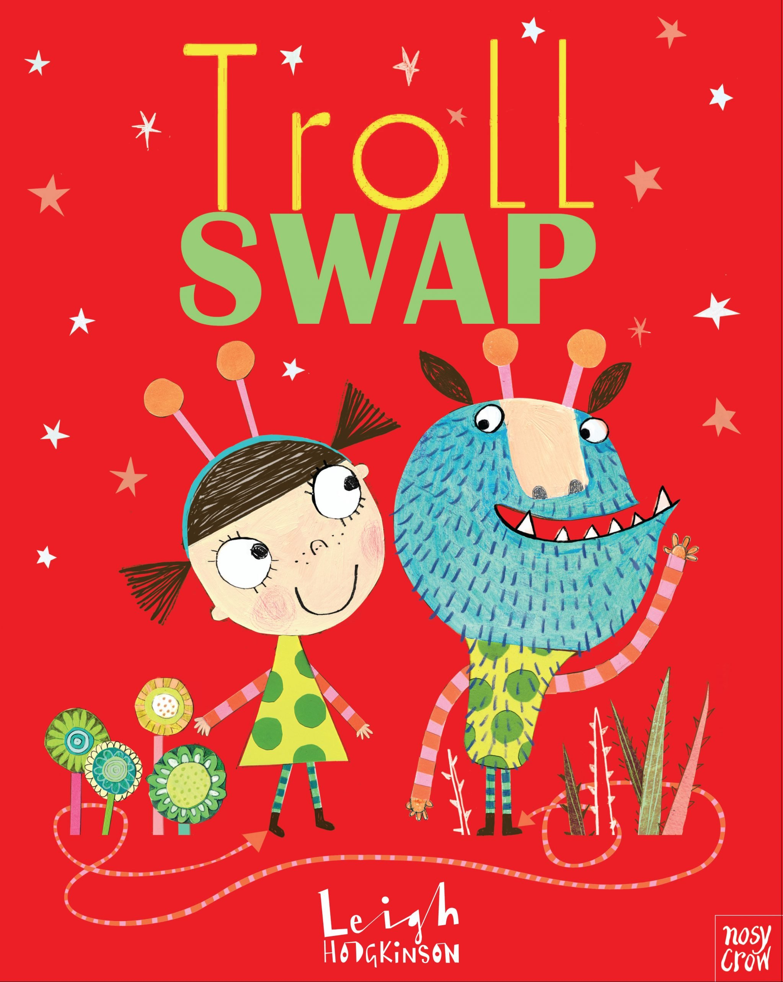
Topic Overview & Key Text
The first book that will lead our learning is ‘Troll Swap’ by Leigh Hodgkinson.

Troll Swap focuses on Timothy Limpet who feels out of place in the troll family because this hairy troll is polite and tidy. Meanwhile, Tabitha Lumpit likes things to be loud, loopy and messy, unlike her very neat family. One day, the two meet and swap places to experience life in someone else’s shoes. Will they finally belong somewhere?
Maths
This half term we will be focusing on place value and addition and subtraction. We will continue to practise and consolidate number skills from Year 1, including counting in 2s, 5s and 10s and number bonds to 10 and 20. We will continue to explore problem solving and reasoning maths questions throughout all of our topics.

Writing
In this topic the children will be exploring how to write their own character swap story. Building on Year 1 learning, we will continue to work on good sentence structure and consistent use of punctuation. We will be learning how to use expanded noun phrases to describe and the conjunctions ‘and’ and ‘because’ to join sentences.

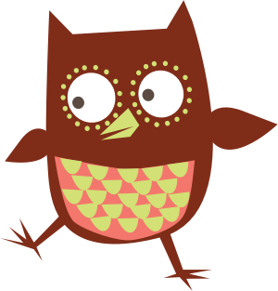
Reading
All children will attend daily reading lessons, where we will continue to use phonic strategies to decode, build our reading fluency and practise our comprehension skills, either through ‘Whole Class Reading’ lessons or the ‘Read, Write, Inc.’ programme.
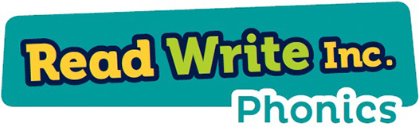

Your child will be issued with a new reading book every Tuesday and Friday. Children are expected to read their book at home every day and reading records should be signed at least three times a week.
Please ensure that your child has their reading book and reading record in their bag every day.

Homework
Maths homework will be set online. We will continue to use SeeSaw to set homework. Homework will be set on a Friday and should be completed by the following Wednesday. Reading should take place each day.

Year 2
We will be continuing with our thematic curriculum that creates meaningful links between the children’s learning in English, science, humanities and creative arts with our key text as the main driver.

Science: ‘Materials and their properties’ – We will be learning about what objects are made from and why particular materials are chosen according to their properties.
DT: ‘Bridges’ – We will research, design, construct and evaluate our own bridges.
Geography: ‘Our Local Area’ – We will be learning about the human and physical features around Longsight.
PSHE: ‘Reconnect Curriculum’ – There will be a focus on wellbeing. We will explore British Values and the Wider World topic.

Year 2
Routines

Mondays | Tuesdays | Wednesdays | Thursdays | Fridays
Spelling Test |  | Homework completed |  | PE – please bring trainers  Homework uploaded  Green Treat

We would like to welcome parents to meet their class teacher on either Monday 5th September or Tuesday 6th September at 9am or 3pm.

School closes for the half term break on Friday 21st October 2022 and reopens on Tuesday 1st November 2022 at 8:40am.

