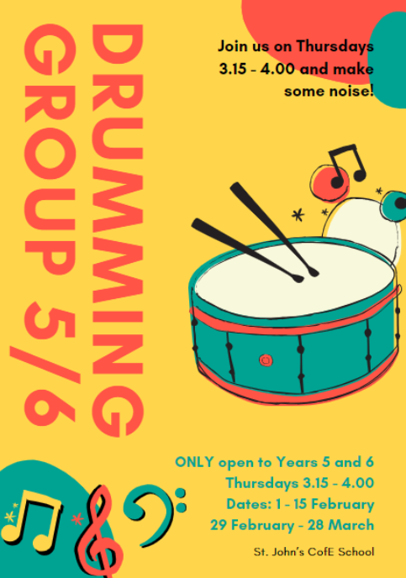Music in KS2 Spring

A drumming group was offered to 30 Year 5 & 6 children in throughout the Spring term.

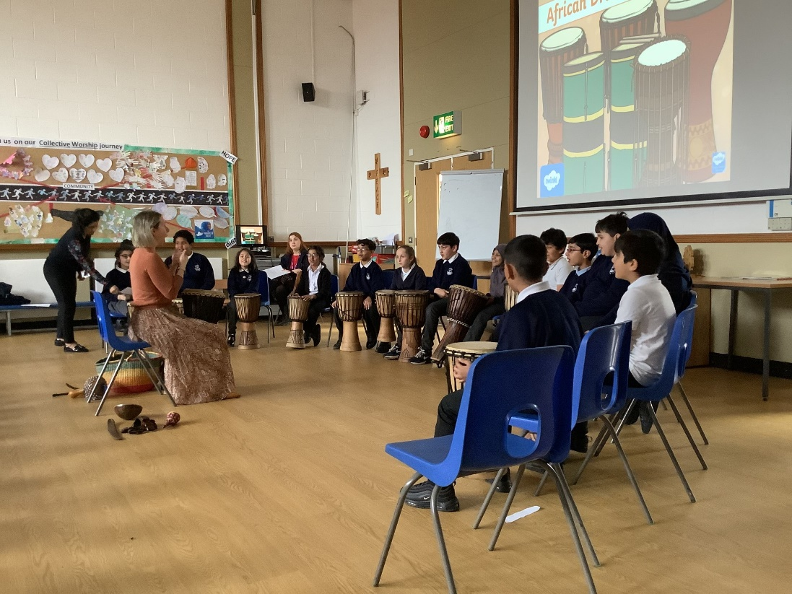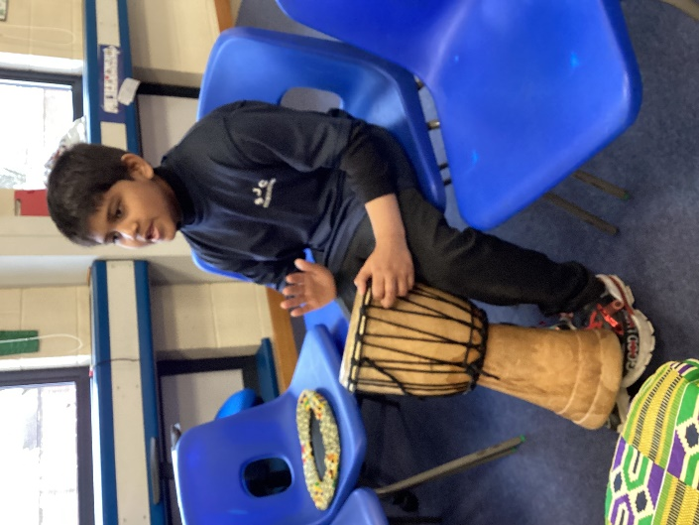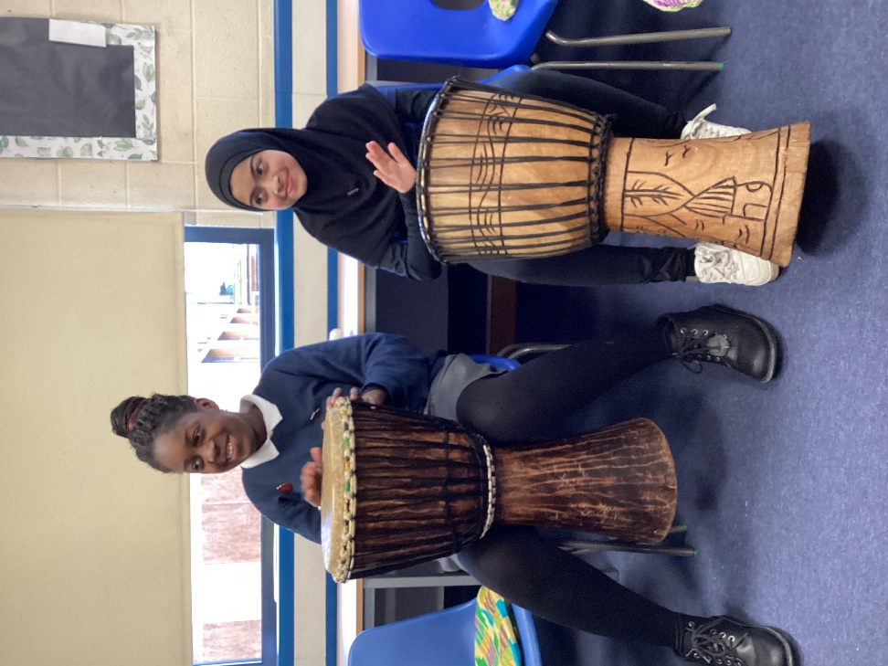

Community

Year 5 have been learning about African drumming and rhythm patterns in their music lessons and used their new skills when performing for parents in their class assembly.