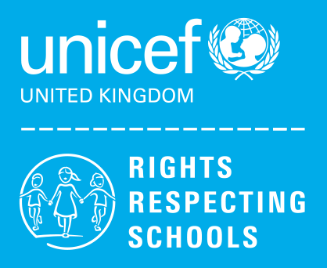Music in KS2 Summer

This term, Year 4 chose Taylor Swift as their Rights Respecting School’s Courageous Advocate. They learned how she overcame bullying to create a supportive community of fans and follow her dreams. They listened to and responded to her music as they learned about her life, finding links to our school values of hope and community.

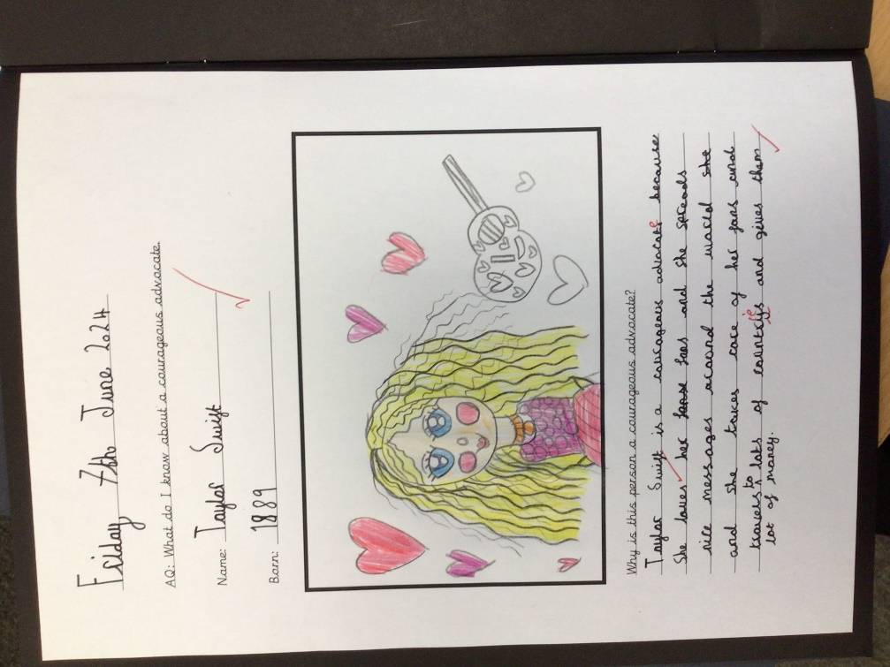

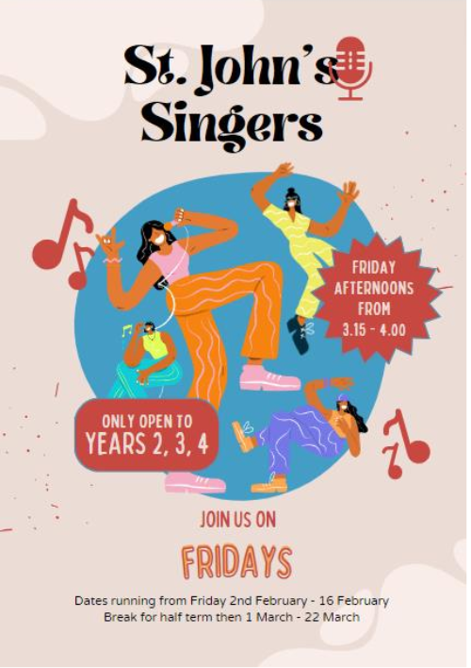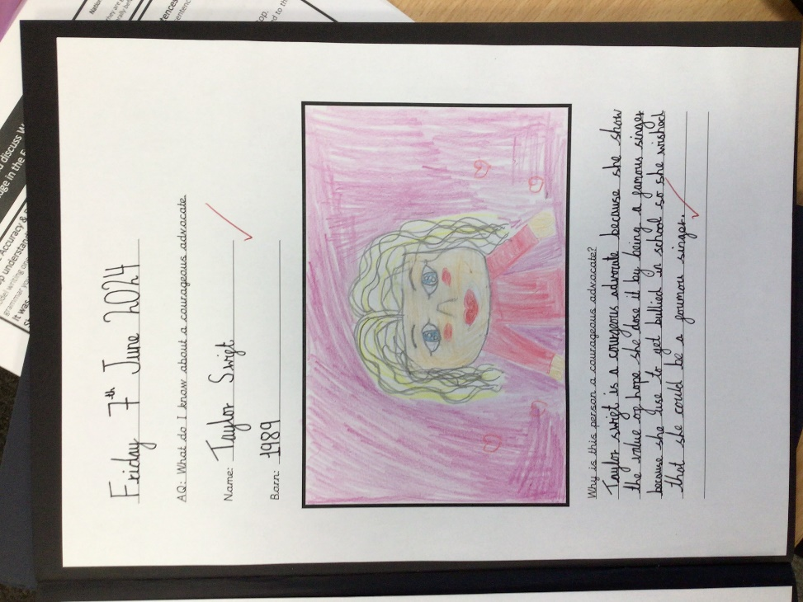

Students feel a sense of community when they sing together.

Key Stage 2 have had a wide range of extra-curricular opportunities, including both singing and instrumental groups offered after school once a week.

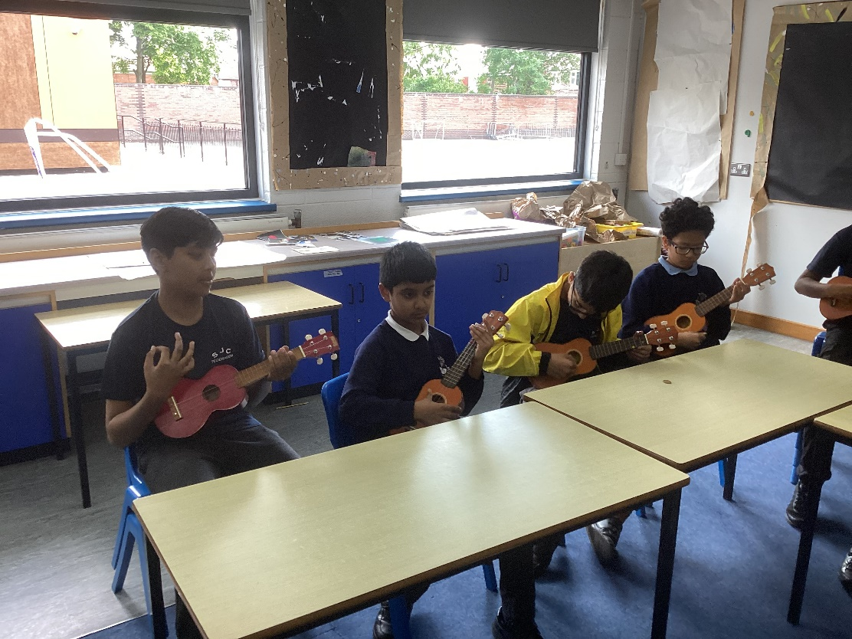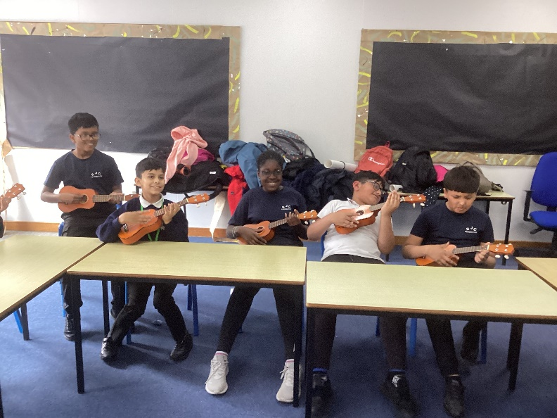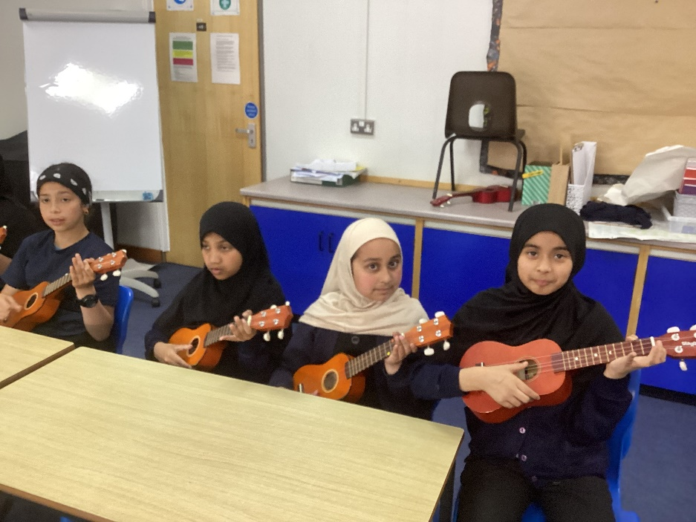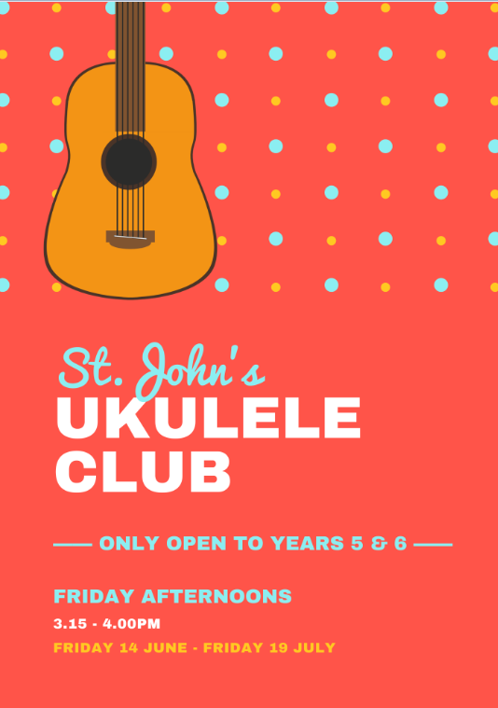

Ukulele group is run once a week. Students learn how to handle and strum the ukulele, using the frets to change the sound and notes played.