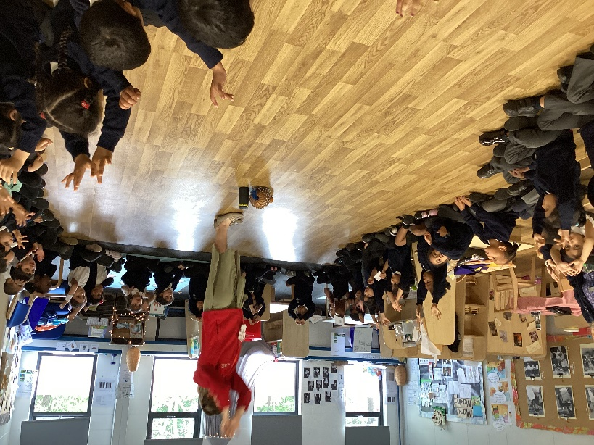Music in EYFS Summer

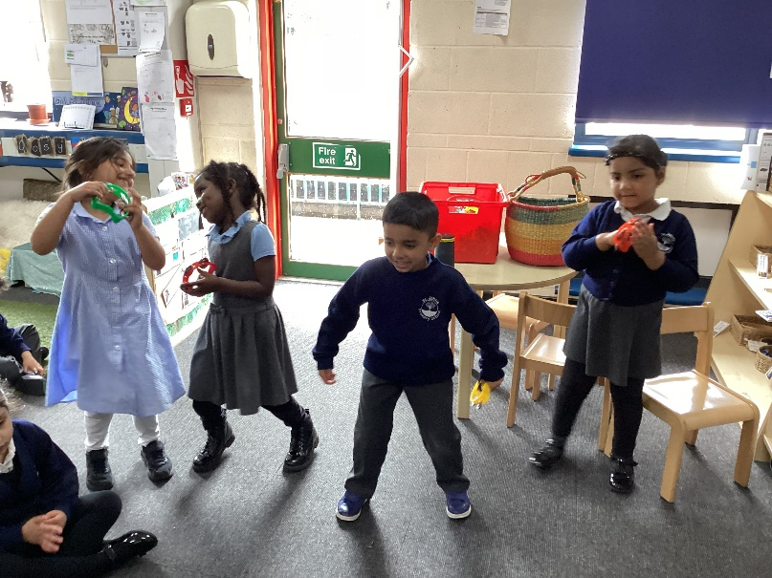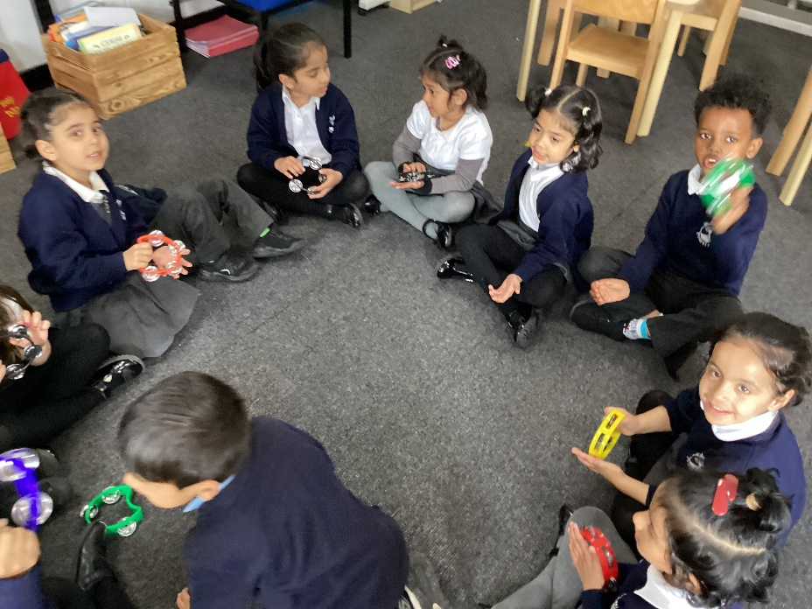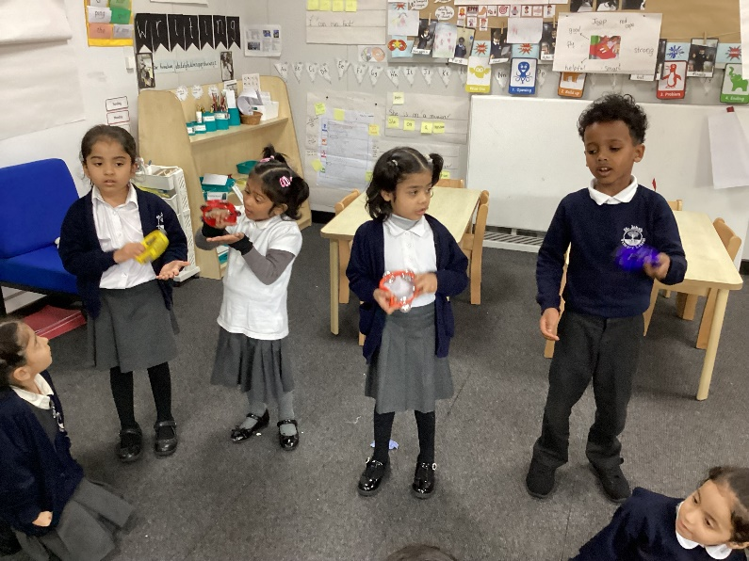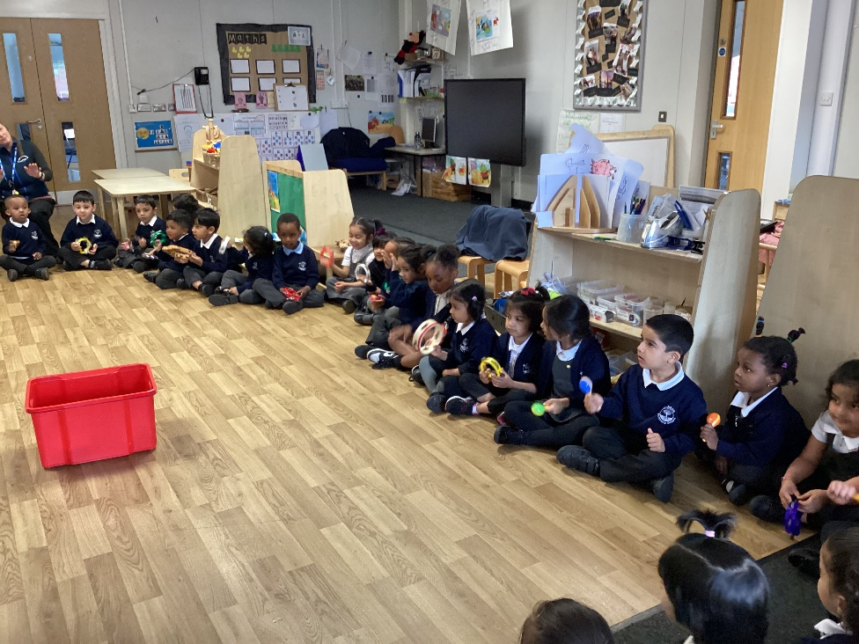

Students dance as they enjoy moving their bodies to the music they are making.

Students in Reception are taking this a step further by learning about rhythm and copying rhythms for the first time. They have also begun making up some rhythms of their own and performing them for their friends and teachers.

Students are beginning to tune their ear in to hear the different sounds made by different instruments (key for their phonic awareness). They are experimenting with how moving the instrument differently can create a different sound.

Students in Nursery have been learning how to move their bodies in response to music and making different sounds with their mouths, voices and bodies. They have also been introduced to some untuned percussion.

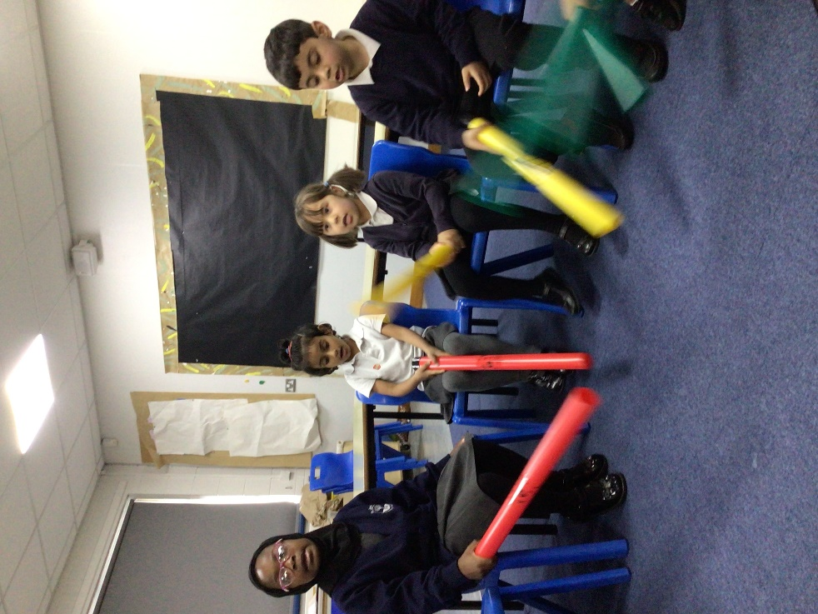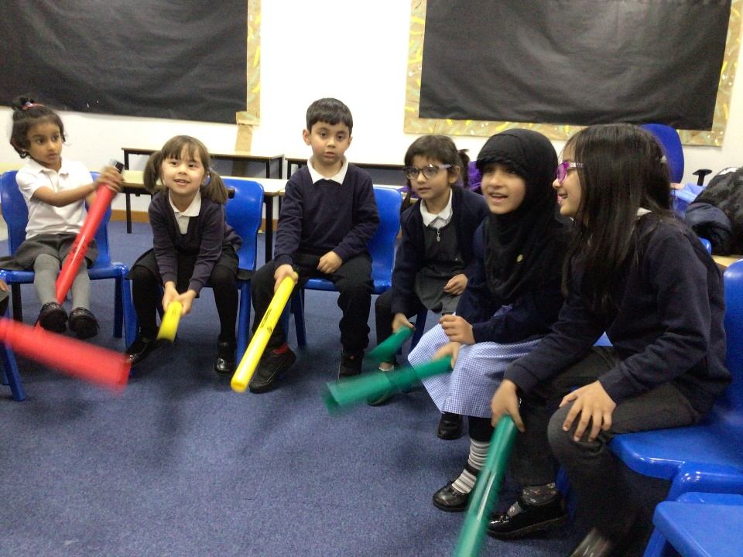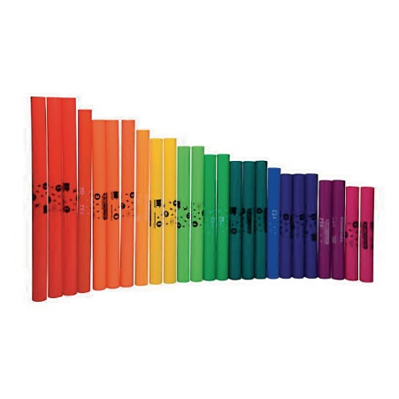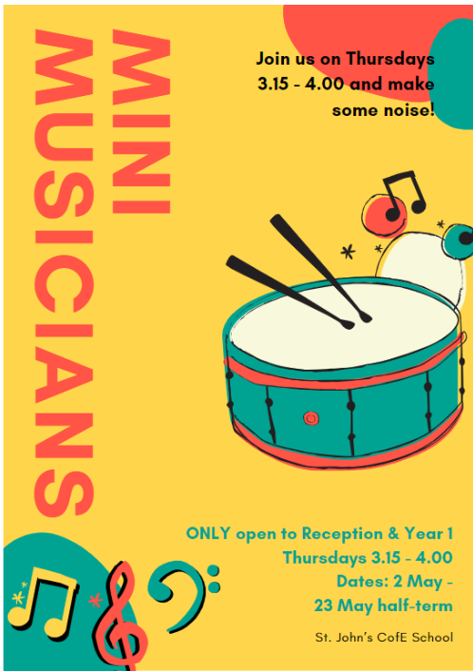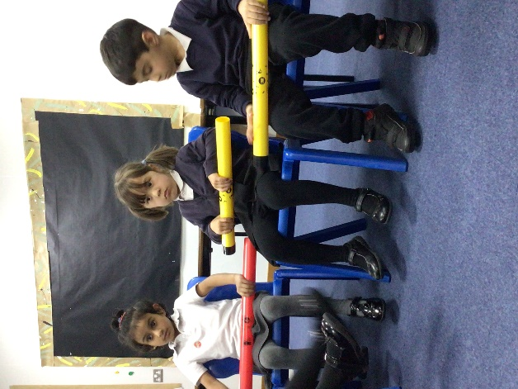

Students show a love for each other by being good audience members and a love for their instruments by taking care of them.

Children learn how to safely and respectfully put their instruments in “rest position” when they are not using them.

Mini Musicians is an afterschool club open to Reception and Year 1. They learn how to use a small range of untuned and tuned percussion, such as boomwhackers, and sing along with some of their favourite songs.