Supporting SEND Through Music

At St John’s, we understand that music, especially singing, is integral to our children’s speech and language development and supporting emotional regulation. This is most true for our children with Special Educational Needs.

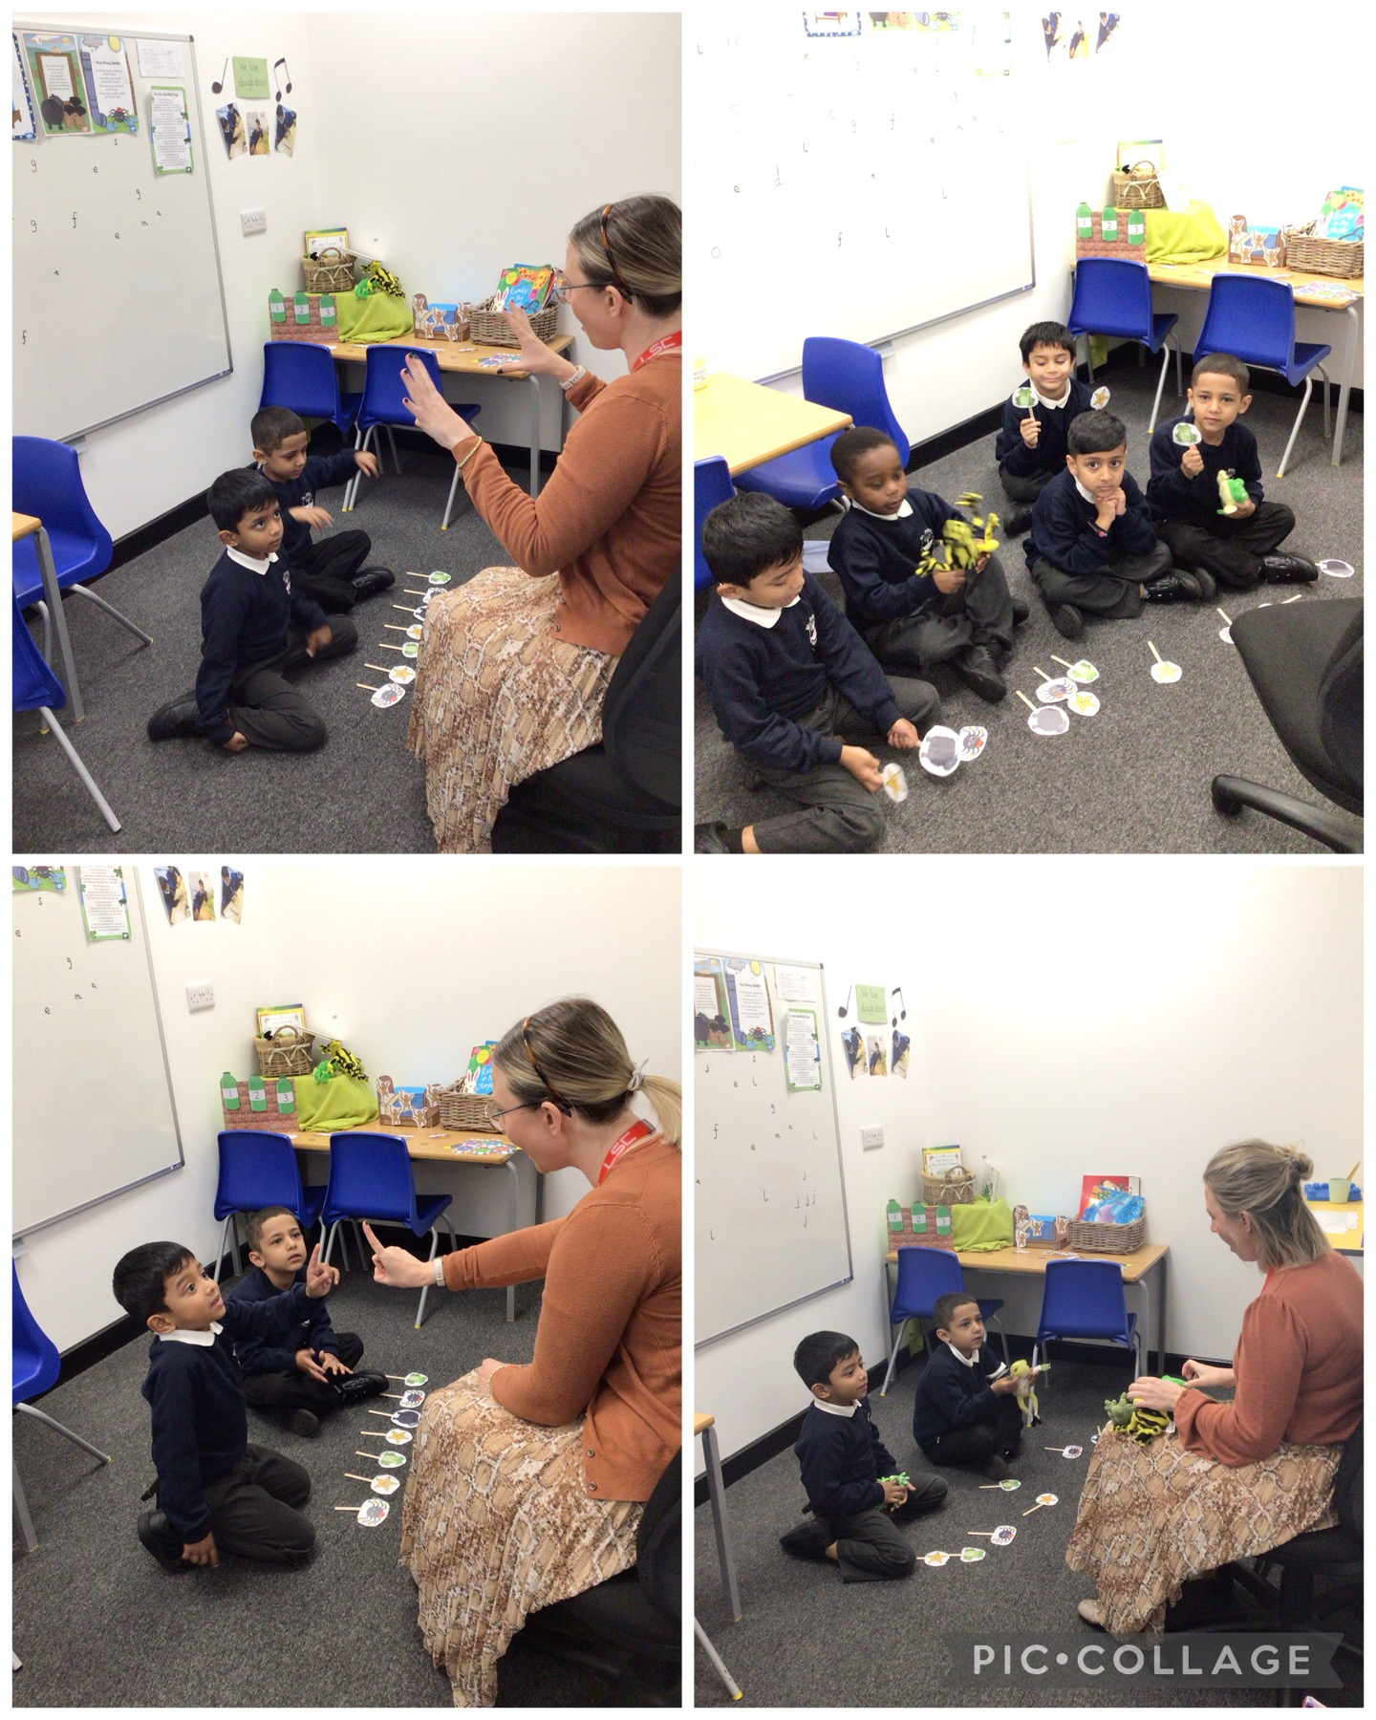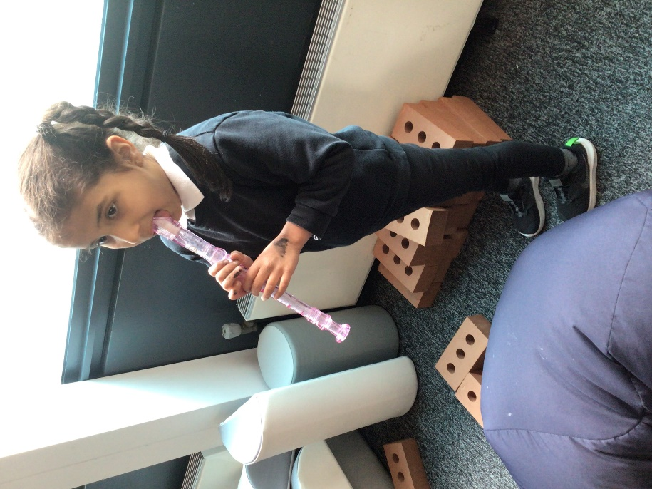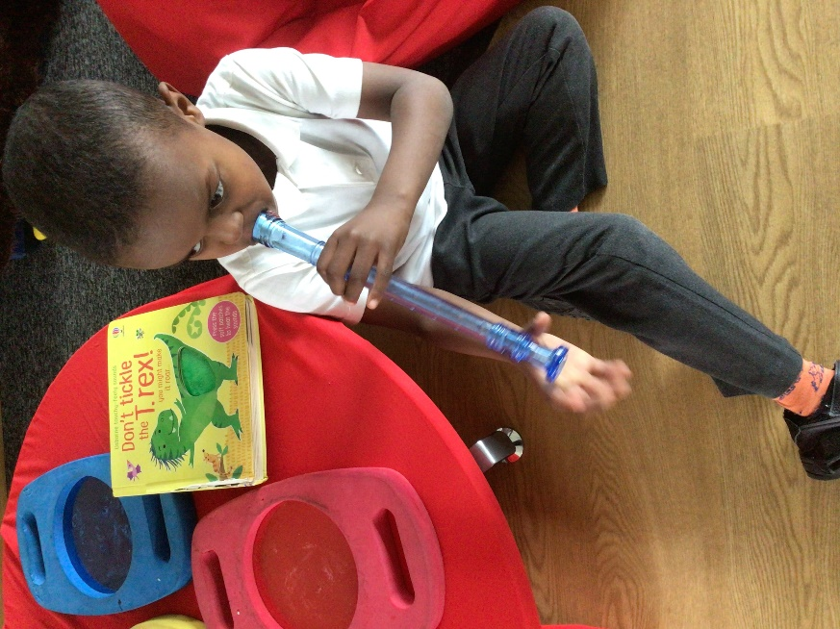

This year some Year 1 children have accessed SALT groups that use music as a tool to support language development. Students sing traditional nursery rhythms to learn new vocabulary and use props to support their learning. This allows students to mimic the patterns of speech and builds anticipation.

We have deliberately included untuned percussion like shakers and instruments such as recorders in our sensory room as part of our SEND provision. Students work on sharing and language skills by asking for a turn with the instrument and enjoy the sensory satisfaction of movement and sound.