Music in KS1 Autumn

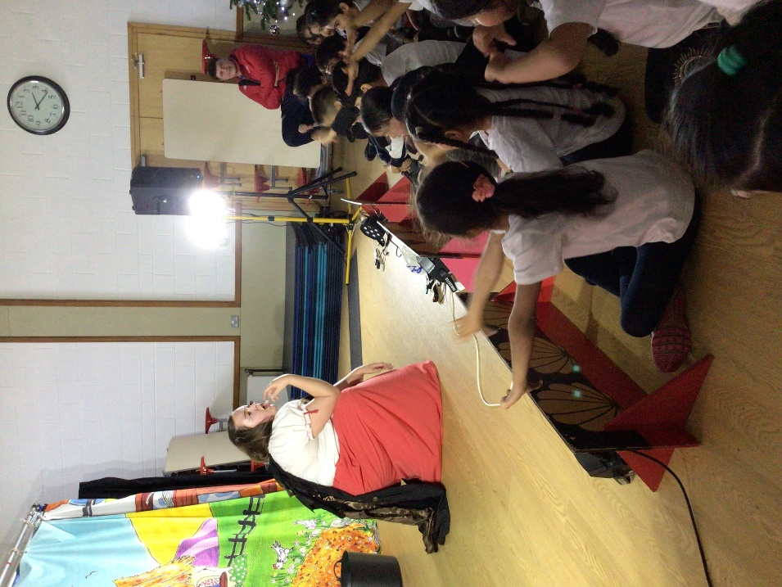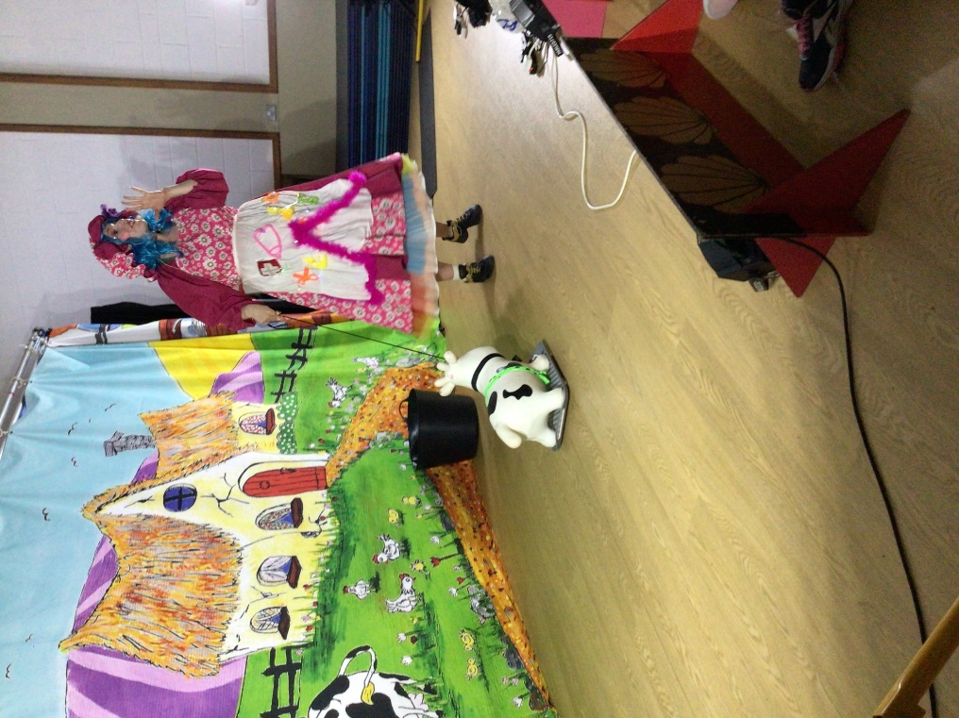Year 1

In the Autumn term African drumming was offered as an after-school club for 20 children from Years 1 & 2.

In December, Key Stage 1 was visited by a travelling Pantomime which included lots of singing and dancing!

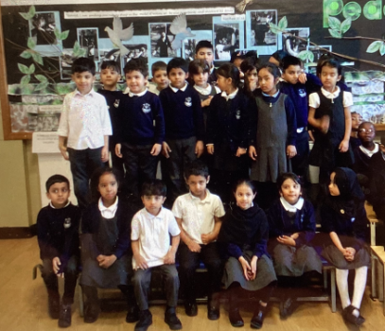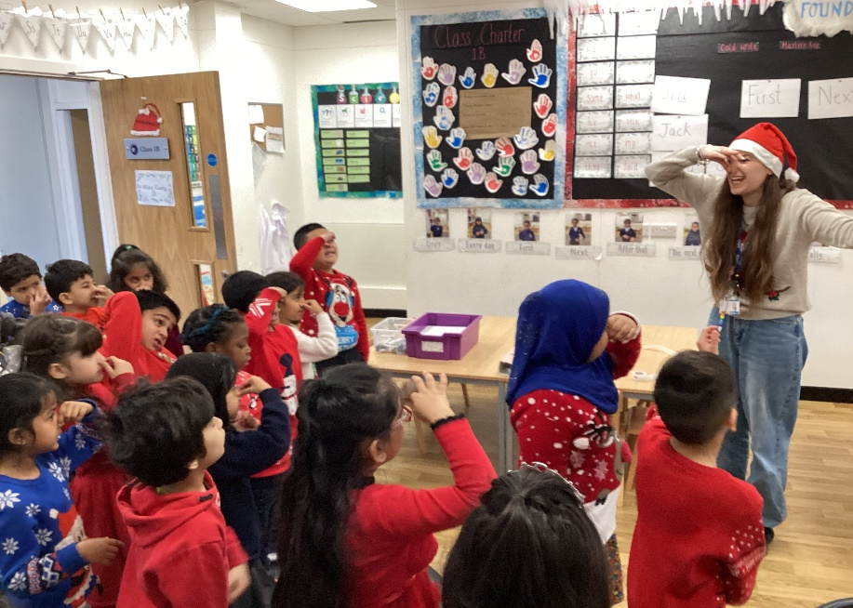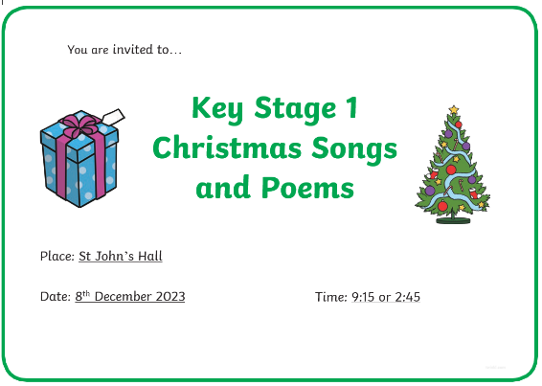

Musical performances bring the St John’s community together at special times of year.

At the end of term, Year 1 & 2 did a combined Christmas show. They sung songs and performed poems for their parents in the hall. We dressed in festive clothing and even designed our own hats!

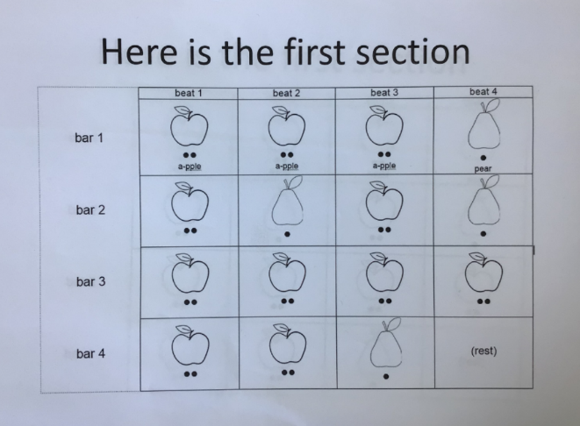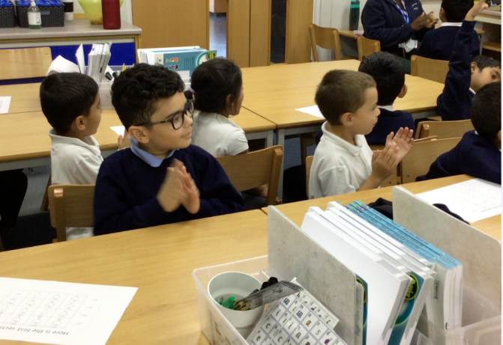Year 2

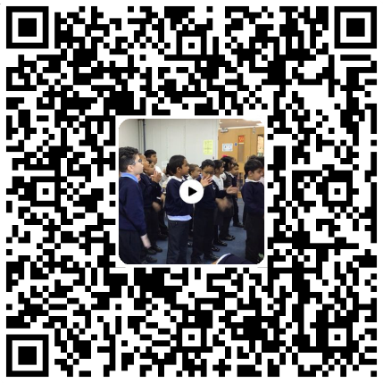

Year 2 were introduced to scores and notation for the first time. They used the syllables of words to help them read and clap different rhythms.

Watch them perform their final piece!