17th May 2024

Dear Parents & Carers,

Thanks for your wonderful support over the last academic year.

We have delivered some inspirational workshops this year to date that have been taught by external speakers. These have included:
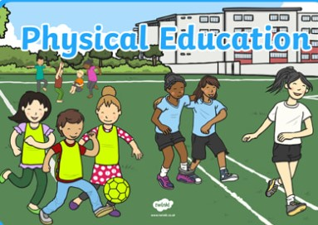
Physical Education
Physical education really matters and
we continue to fund external sports coaches
each week so that all children have a great
experience each week.
Please do send the correct kit on the relevant days.

Competitive sport
We have a regular inter school sport afternoon
each term for our children in year three, four, five
and six. This allows the children to compete against
children in our sister school from St. John's.

After-school sport clubs
Clubs are usually paid for by parents.
However, from May - June school has set money aside to fund some sports clubs for free for six weeks. See attached form for you to complete should you want to apply for a place.

Some dates to remember ...

Parent Evenings:
Monday 24th June, 3pm – 6pm
Tuesday 25th June, 3pm – 6pm

Sports afternoon:
KS 2 – Monday 1st July 2024
KS 1 – Tuesday 2nd July 2024
Nursery – Thursday 4th July 2024

Year 6 Leaver’s Party:
Monday 22nd July 2024, 5pm – 6.30pm
Year 6 Assembly:
Tuesday 23rd July 2024 – 2pm

Last day of Term:
Tuesday 23rd July 2024

Our ongoing commitment to your children

Sports wear
All children in year three, four and five will have new sports tops provided later this month.

Early years outdoor coats.
We remain fully committed to providing a new outdoor warm coat for our reception children in September.

Class trips: summer term 2024
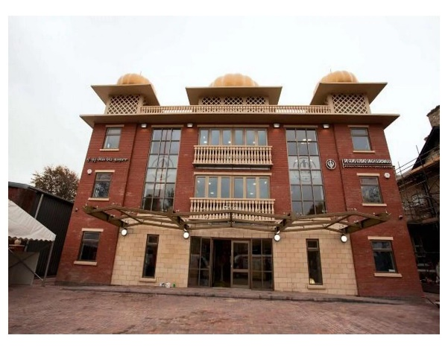
All children in key stage two have taken part in an assembly and some year six workshops with the blind football coach, Azeem Amir. He was a really lively speaker and relatable to the children.
Again, this ensured we have exposed our children
to young black role models this term.

Children from year five have already
visited the local Sikh temple.
It is helpful for all children to understand
the different faiths that exist and we are
grateful for your support in developing a good
understanding and tolerance of faiths.

Year four have visited the Manchester central library to meet an author, Steven Butler and hear about his work and latest published books including Humbug: The Elf who saved Christmas, You Ain’t Seen Nothing Yeti and The Nothing to See Here Hotel.

Class trips in the new academic year 24/25
We have already booked and are committed to funding an inspirational theatre experience in December next year. We plan to take all children in year 4, 5 and six next term to enjoy the Christmas pantomime being performed at Stockport Plaza Theatre. Each ticket and coach cost amounts to £15. This will be entirely funded by school.

Our younger children will enjoy a performance in school of a live theatre show, again at no charge.

Our new Head of School
Our governors have worked hard to support me to recruit a new head of school. He will meet the children and families when he begins his role in September. As planned I have enjoyed spending more time at St Chrysostom's each day to ensure the school continues to run smoothly over the rest of this term.

Thanks again for your support. If you have questions about any aspect of school lessons or events please come and see me on the gate in the morning I am happy to speak to you.

Yours faithfully.

Mr. G. F. Elswood
Executive Headteacher

